Referral for Diagnostic Imaging
Call for appointments: 8512 0706
Fax number: 8692 9917
Appointment Time: Date: / /
Name:  Address:  Requested Diagnostic Imaging:  [ ] X-Ray [ ] Ultrasound [ ] OPG [ ] Lat Ceph  [ ] Doppler Ultrasound [ ] SWE (Fibroscan) |  | Date of Birth:  Telephone:  Medicare No. :  Clinical Notes:
Referring Doctor: | Patient Category:  [ ] Medicare Card (bulk billing)  [ ] Private billing  [ ] Work Cover  [ ] TAC  Female patients: Is there any chance the patient may be pregnant?  [ ] Yes [ ] No |  |  | Results:  [ ] Electronic  [ ] Telephone  Fax to:  [ ] Films to patient  [ ] Copies to:

Doctor’s Signature: Date of referral:

You are free to choose your imaging provider. We accept all referrals:
Green Radiology (Clayton)  Shop T.50F, Mezzanine Level, M-City Monash,  2107-2125 Dandenong Road, Clayton, 3168 | Phone: 8512 0706  Fax: 8692 9917  Email: adminclayton@greenradiology.com.au

(FREE Parking. Best parking on B1 with signs to medical suites. Pedestrians, from Blackburn Road entrance, first left and then up the stairs or elevator to Mezzanine Level).
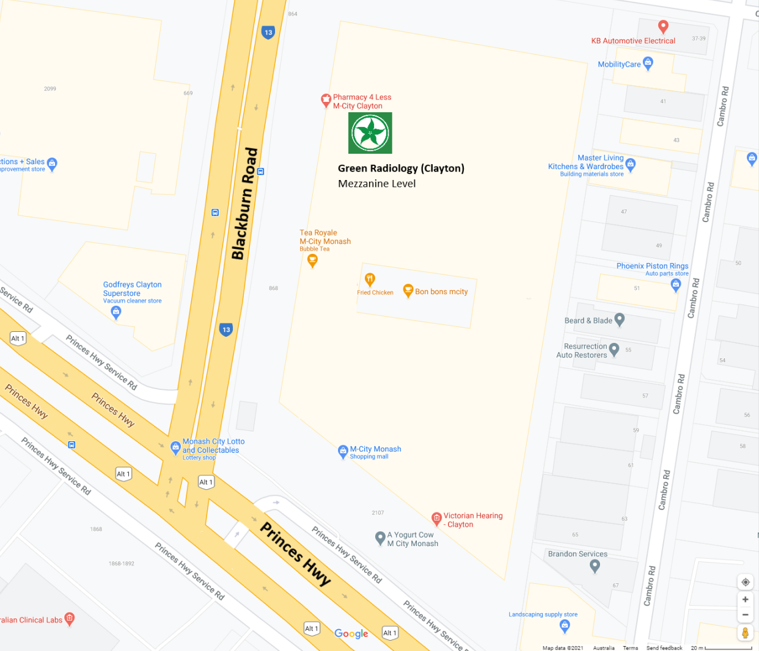  Google Maps data ©2021 | https://www.greenradiology.com.au/  https://www.facebook.com/greenradiology.com.au/  https://www.instagram.com/greenradiology/  https://au.linkedin.com/company/green-radiology  https://twitter.com/GreenRadiology  Green Radiology (Clayton) Pty Ltd  ABN: 56 641 509 935

